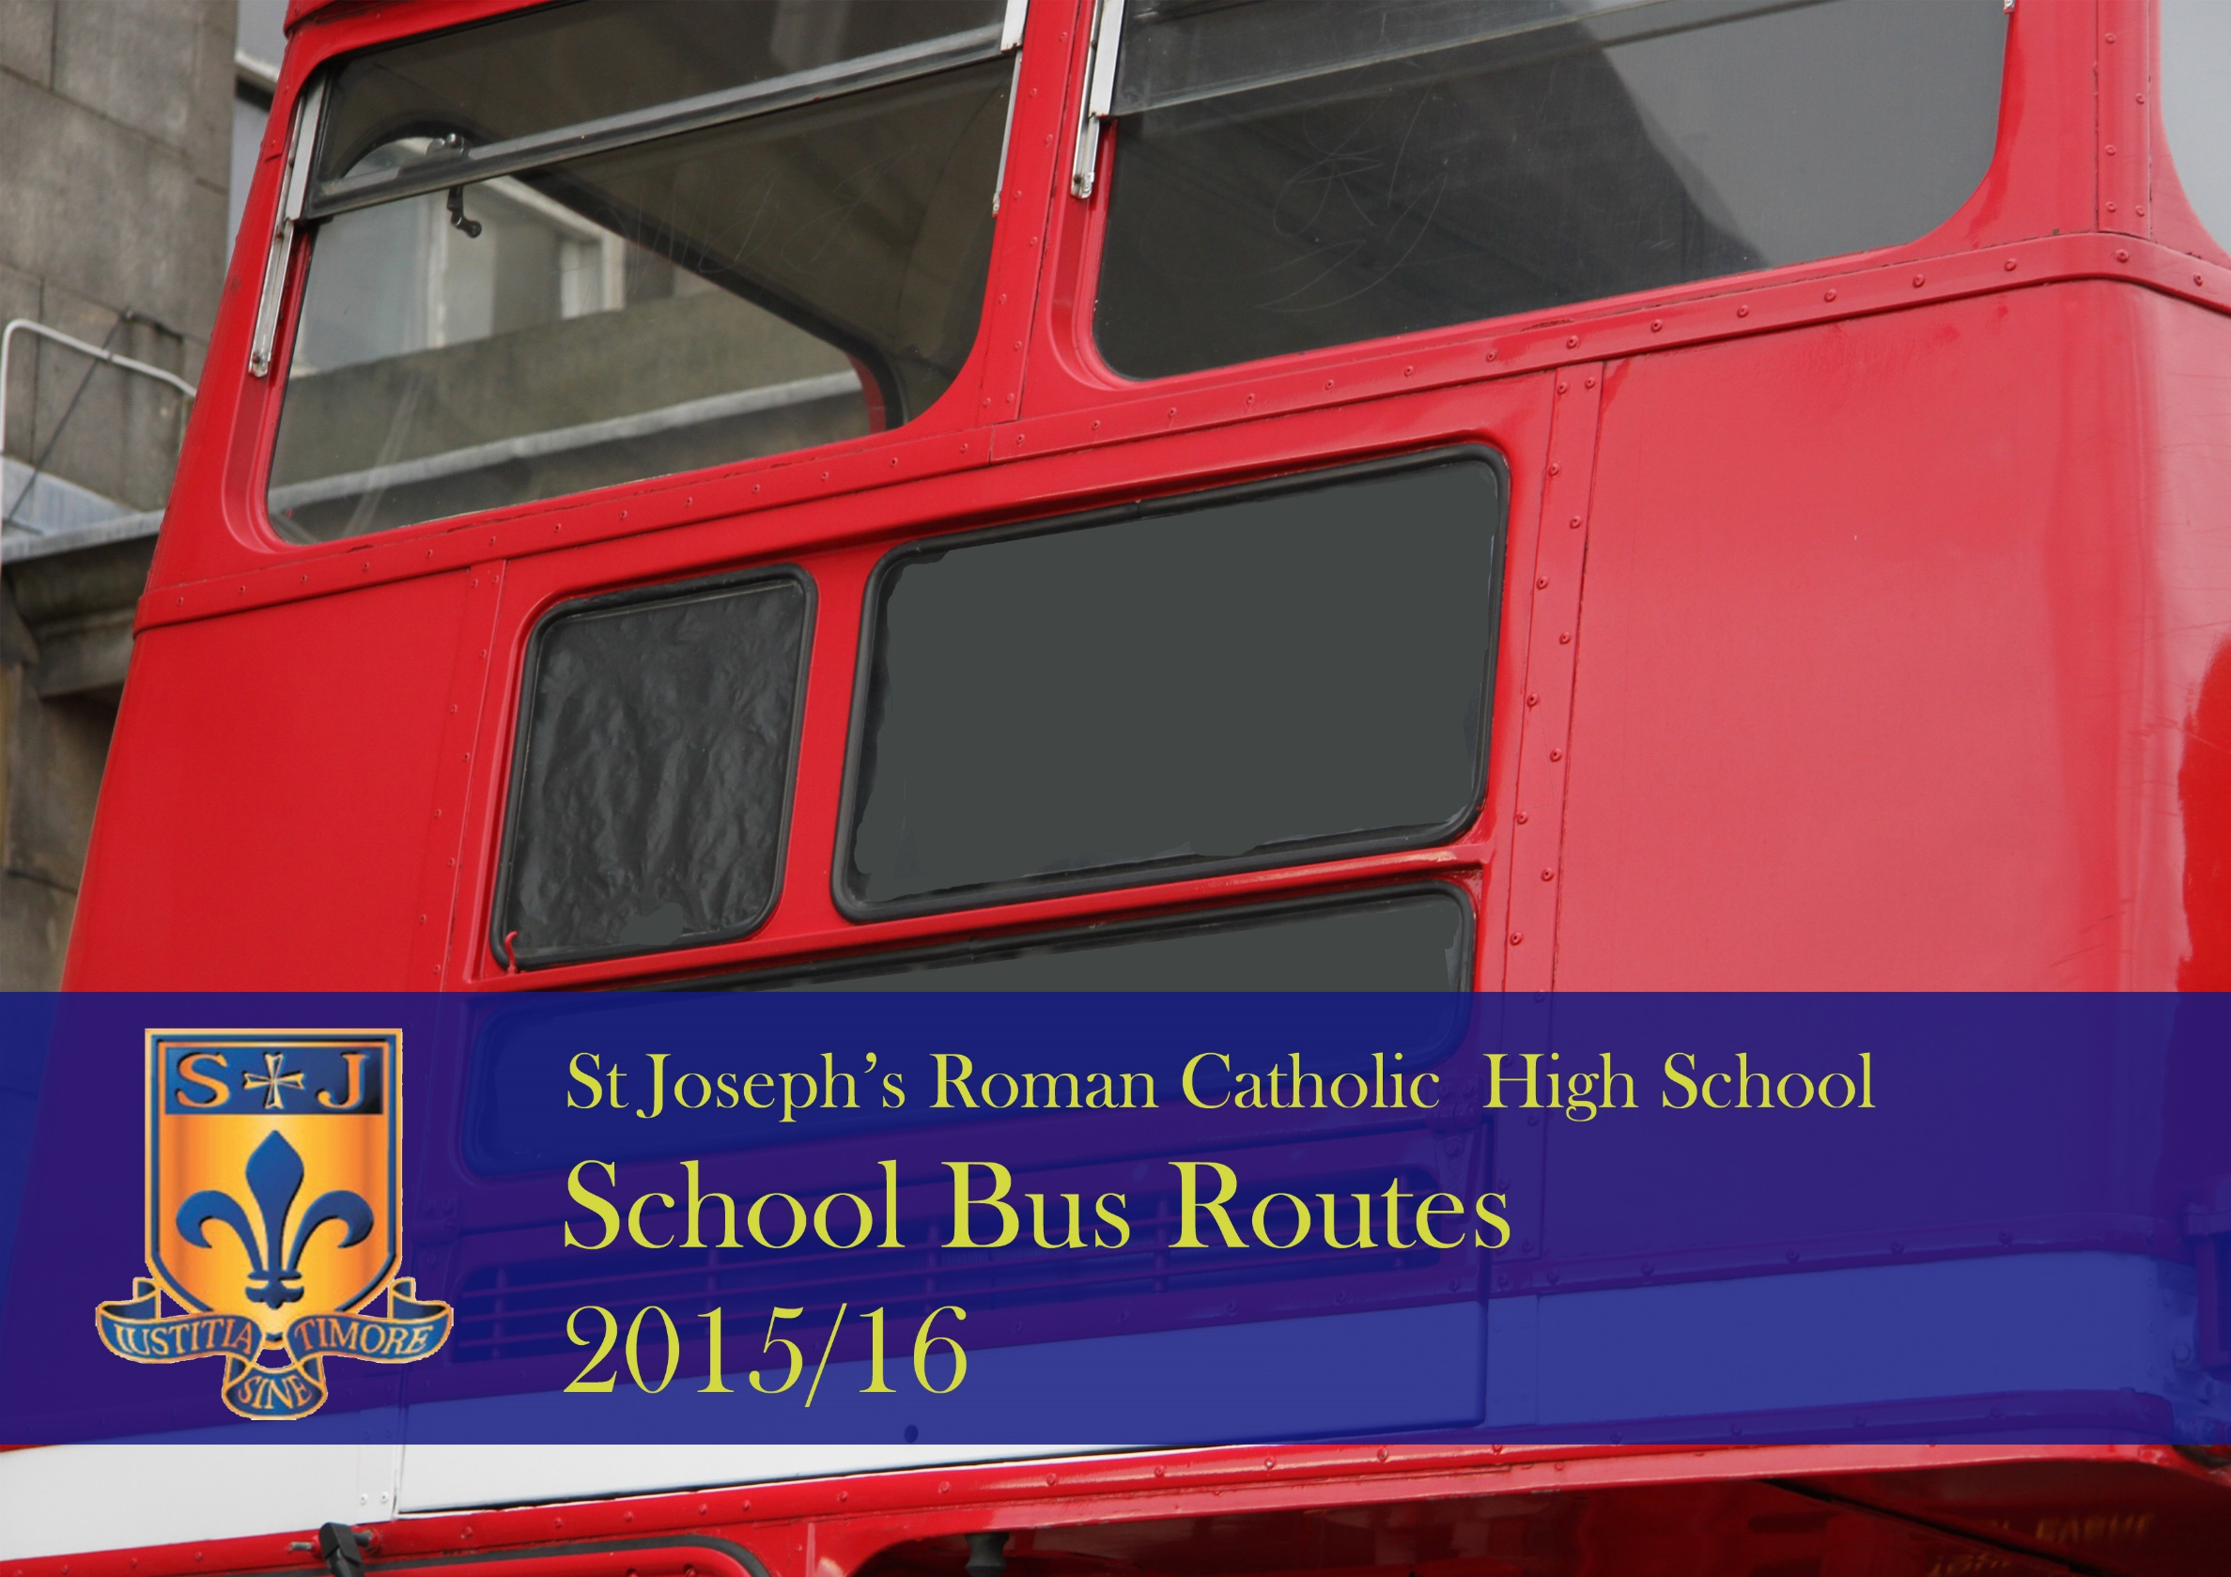

School Bus Routes
Wigan 2
Ashbourne Avenue (8.10am)
Tamworth Drive
Whelley
Wigan Road
Fingerpost
Bolton Road
Dicconson Lane
Chorley Road
Lostock Lane
Lostock Road
De Havilland Way
Chorley New Road

Wigan 1
Crown, New Springs (8.10am)
Wigan Road
Fingerpost
Scot Lane
Manchester Road
De Havilland Way
Chorley New Road

Wigan 4
Wynsors Shoes, Scholes (8.10am)
Whelley (Bradshaw Street)
Wigan Road
Fingerpost
Bolton Road
Gerrard Arms
Dicconson Lane
Chorley Road
Lostock Lane
Lostock Road
De Havilland Way
Chorley New Road
Wigan 3
Holly Road (8.10am)
St David’s Crescent
Haigh Road
Ratcliffe Road
Stanley Road
Scot Lane
Manchester Road
De Havilland Way
Chorley New Road

The Wigan coaches are all operated by Grayways coaches. The starting point on each route is 8.10am. The designated pick up points are shown in italics . The return journey is the reverse of the above routes.

516 (Four Lane Ends) a.m.
Four Lane Ends 7.45am
Manchester Road
Chequerbent
Manchester Road
Bolton Road
Market Street
Church Street
Chorley Road
Lostock Road
Lostock Lane
De Havilland Way
Chorley New Road
996 Bolton Royal p.m
Chorley New Road
De Havilland Way
Lostock Lane
Lostock Road
Chorley Road
Manchester Road
Bolton Road
Park Road
Manchester Road
St Helen’s Road
Morris Green Lane
Lever Edge Lane
Green Lane
Bradford Road
Minerva Road
Ridgate Way
Royal Bolton Hospital

The bus routes on the 516 / 996 (formerly 521) bus are different for the am and pm journey. Both routes are operated by Arriva buses. As they are designated as service buses they will stop at all bus stops.

915 Bolton, Ladybridge, Lostock
am Arriva pm Wigan Coachways
Bolton, Black Horse Street 7.50am
Deansgate
Moor Lane
Deane Road
Wigan Road
Beaumont Road
Armadale Road (Clockwise Loop)
Broadford Road
Armadale Road
Beaumont Road
Junction Road West
Tempest Road
New Tempest Road
St John’s Road
Chew Moor Lane
Bolton Road
Manchester Road
Chorley Road
Lostock Road
Lostock Lane
De Havilland Way
Chorley New Road

615 Blackrod
am South Lance Stagecoach
pm Wigan Coachways
New Street 8.05am
Manchester Road
Tanners Brow
Station Road
Crown Lane
Lever Park Avenue to RBHS
Return down Lever Park Avenue
Scholes Bank
Lee Lane
Victoria Road
Chorley New Road

The bus routes on the 915 and 615 follow the reverse route on the pm journey. As they are designated as service buses they will stop at all bus stops.

516 Daisy Hill / Gray Man
am South Lancs Travel
pm Arriva
Daisy Hill Church 7.50am
Lower Leigh Road
Leigh Road
Cricketer’s Way
Mill Street
Market Street
Church Street
Chorley Road
Lostock Road
Lostock Lane
De Havilland Way
Chorley New Road
Adlington (811)
am & pm UK Coachways
Chorley Road 8.10am
Westhoughton Road
Market Street
Park Road
The Common
Park Road
Market Street
Westhoughton Road
Skew Bridge
Chorley Road
Bolton Road
Scholes Bank
Chorley New Road

The bus routes on the 811 and 516 follow the reverse route on the pm journey. As they are designated as service buses they will stop at all bus stops.

The 516 follows a slightly different route on the last part of the return journey. Both buses are designated as service buses so will stop at all bus stops.
516 Hart Common
pm Tyrers Coaches
Chorley New Road
De Havilland Way
Lostock Lane
Lostock Road
Chorley Road
Manchester Road
Church Street
Market Street
Mill Street
Cricketer’s Way
Leigh Road
Hindley Road
Wearish Lane
Wigan Road
Bridge Street
Market Street
Atherton Road
Hindley, Bird I,th Hand

516 Hart Common
am UK Coachways
Hindley Market Street, Albert Street (7.37am)
Bridge Street
Castle Hill Road
Wigan Road
Wearish Lane
Hindley Road
Leigh Road
Cricketer’s Way
Mill Street
Market Street
Church Street
Chorley Road
Lostock Road
Lostock Lane
De Havilland Way
Chorley New Road

