September 2019 Uniform
Thank you to all those who participated in our uniform consultation 18 months ago. The new items have now been manufactured and are available from our suppliers (listed below and on our website) from June/July.
New dark blue embroidered blazer with white shirt/blouse underneath and tie, Y7 – Y10
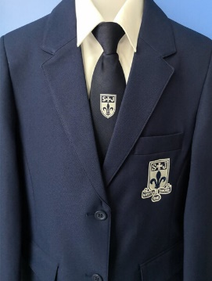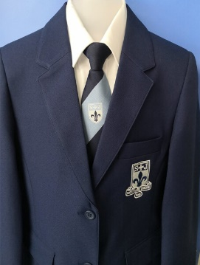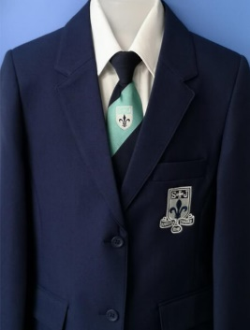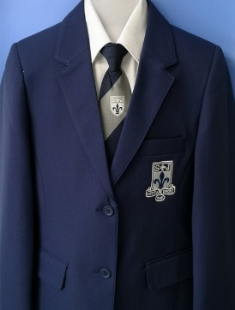
Navy tie – Y7 Pale blue stripe - Y8 Aqua stripe - Y9 Pale grey stripe - Y10
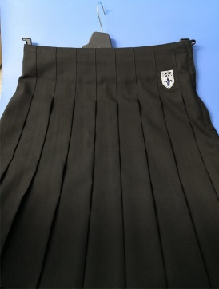
New Black pleated skirt with logo on hip Y7 – Y11
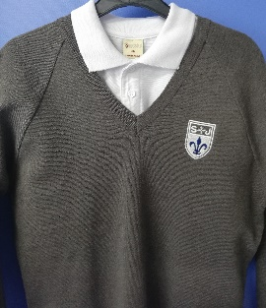
New grey embroidered jumper with a white polo neck underneath, no tie – Y11 only
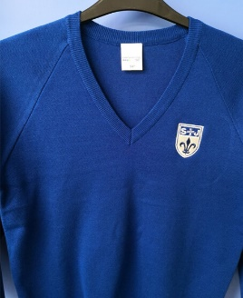 New optional royal blue jumper, to be worn under blazer and with tie, Y7 – Y10. This item is non-compulsory to keep the cost of the uniform down if you wish to. This can always be purchased at a later date if you find your child needs one.
There are no proposed changes to the compulsory:
- Trousers – (plain black, not skinny style or jean cut)
- Socks – black ankle or knee length
- Shoes – plain black sensible - (no coloured logos, stripes or fabric. We are defining a shoe as something you can put black polish on and the ankle is uncovered – please see below)
- White polo shirt for Y11 (No tie)
- A plain waterproof coat (this can be any colour so long as it is plain – please consider road safety for dark mornings/nights)

Our compulsory PE kit stays the same:
- Black PE shorts or track bottoms or leggings
- Black PE T-Shirt

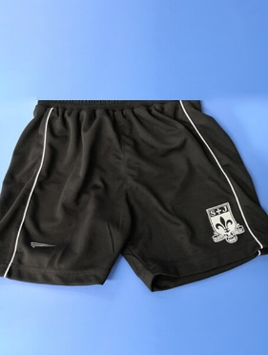 or 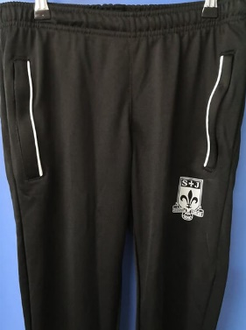 or 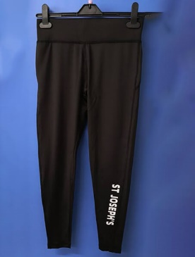 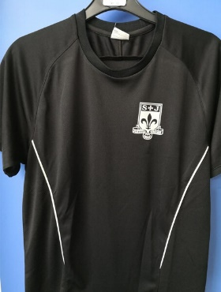
And the optional PE Kit extras: Black ¾ zipped jacket, Black zipped jacket
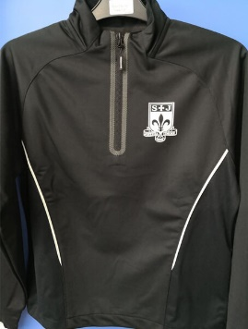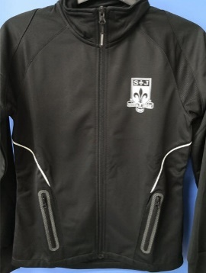

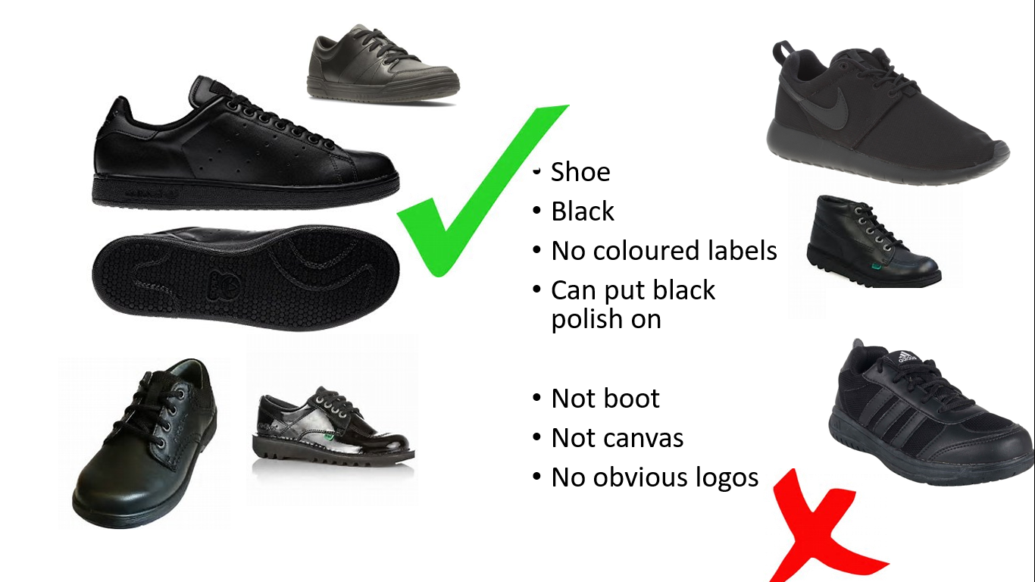
Please note that our suppliers have all worked with us during the uniform consultation process and they have been instructed to refuse sale of skirts failing to reach the knee. If all students wear their uniform as designed there will be no peer pressure to flaunt the rules.

Please note the following when considering footwear…

Please also note: Students must not wear nail varnish or false nails, jewellery, hoodies, track tops or have any piercings (Nose, ear or tongue)
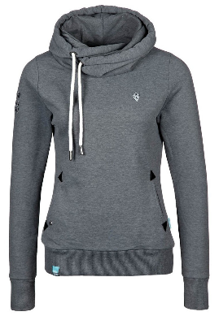

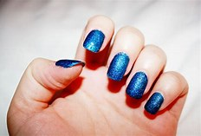
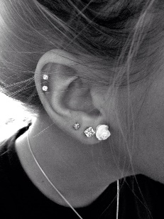

Our Suppliers:
Contract Schoolwear (01204) 62464
Andrew Leach’s Schoolwear Horwich (01204) 697624 http://www.andrewleachschoolwear.co.uk/
Whittakers Schoolwear, Bolton (01204) 389485 www.whittakersschoolwear.co.uk
Aspull Village Embroidery, Aspull (01942) 830153https://www.aspullvillageembroidery.co.uk/stjosephs/

We would like to take this opportunity to thank you for your continuing support. Uniform is monitored daily and currently almost 100% of St Joseph's pupils turn up in the correct uniform. This is a huge support and enables us to focus on our core purpose of Learning & Teaching and, ultimately on your child's on-going success.

