St Joseph’s RC High School
Cautious Opening for Y10 15th June 2020
This letter is intended to give you details about school opening for Year10. Once you have read it please click here to let us know if you would like to book a place for your child. https://forms.office.com/Pages/ResponsePage.aspx?id=sHAoOFeTq0ONO_0gvTFzyl1aqAsCO9NKjXsSdB3996xUQ0tGTzFLRTU4RkI3RVhDTDJJNFVHQVVLMS4u
It is vital that we have exact numbers to ensure that we can plan for social distancing.
Opening school to more students involves risk of infection. We have done our best to reduce the risk but nevertheless the risk is still present. It is therefore a decision for each family to make on whether to send their Y10 child into school between Monday June 15th and Friday 17th July. This document is supported by a risk assessment available on our website and is designed to establish a community approach to keeping any risk to a minimum. The arrangements are subject to change if it becomes unsafe to open or if we are directed to change plans by the government.
Recently the Department for Education published an overview of scientific advice and information on coronavirus (COVID 19)
It states that there is a high degree of confidence that children who are infected with Covid-19 tend to have less severe symptoms than adults who are infected: children are often asymptomatic or have a mild course of illness. Serious COVID19-related illness and death amongst children and young people is extremely rare: mortality seems to be consistent at around 0.01% - in a similar region to seasonal influenza. However, please stress with your child that if they fail to social distance and contract the virus they are putting staff, parents/carers/vulnerable relatives’ lives at risk. Therefore, by sending your child into school you are agreeing that your child will follow the protocols contained in this document.
Please ensure that you have shared these principles with your child before they return to school on the 15th June – particularly the expectations around conduct on site.
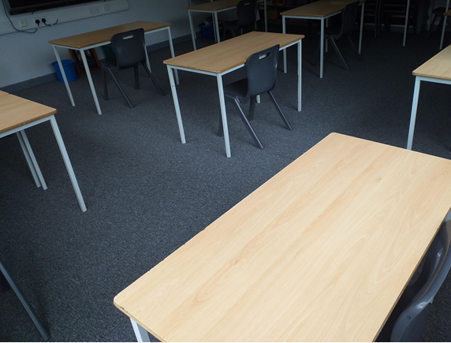
Who will be allowed in school and when?
From Monday 15th June Year 10 have been split into four cohorts. Quarter of the year group (less than 45 students - we will call a bubble) will be in on a Monday to Thursday. A different cohort each day. The school day for Y10 will be from 8:30-1pm. They will stay in one learning group at all times (A safety cocoon). A safety cocoon will have a maximum of 15 students in. Learning in school will supplement online home learning and not replace it. Each ‘bubble’ will have its own staff and member of SLT who will act as duty manager each day. Different ‘bubbles’ will not mix.
Children of key workers and vulnerable learners will be supervised on site by prior notice with the same arrangements previously in place. Our dedicated email address supervision@st-josephs.bolton.sch.uk can be used for queries relating to this.
How will my child get to school?
We encourage students to either walk or cycle to school where safe and reasonable to do so. Please ensure that your child wears a helmet if they choose to cycle. Bikes can be stored on the tennis courts. This will be locked during the school day. If students are being dropped off please enter the school site via the Sefton Lane entrance and leave by the normal exit. At 1pm the bus bay will be full so it will not be possible to leave the site by car this way.
If your child walks or cycles to school or travels by public transport please make sure that they are socially distant with their friends – especially resisting the temptation to hug/shake hands etc. after not seeing each other for such a long time. Buses will fill up from the back and students will be asked to leave seats with a 2m gap between each other.
All buses will run as normal (from Monday-Thursday) but the Wigan buses will be combined. There will be one bus following this route:
- Ince bar (KFC) - 07.35
- Scholes, Opp Windsor shoes - 07.40
- Whelley/ Bradshaw st - 07.42
- Ashbourne ave - 07.45
- Wigan Rd / Crown hotel - 07.47
- St. David’s crescent - 07.50
- Haigh Rd / Holly Rd - 07.52
- Aspull Fingerpost - 07.55
- Bolton Rd / Gerrard arms - 08.00
Arrive school - 08.15
On entry to school where should my child go?
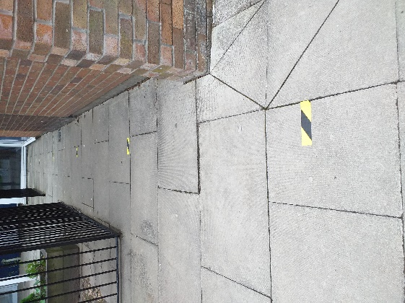
In order to reduce unstructured time and possible infection students should not come onto site before 8am and we suggest that they aim for 8:20-8:30am. On entry to the site students should wait 2m apart from each other on the driveway until safe to enter, using the markings as indicators. Only one person can enter reception at any one time. Students must wash their hands and then wait on the yard until 8:20.
Students should sit or stand on a 2m marker on the yard to be sure of social distancing. From 8:20am students should go straight to their classroom (where they will be taught in their learning ‘Safety Cocoon’) walking on the left using the 2m guides as indicators.
Attendance registers will be taken at the start of the day in your child’s ‘Safety Cocoon’ at 8:30am
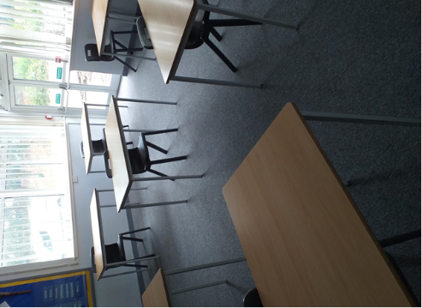
Students will have their own desk where they will sit in every lesson. It is solely for their use. Equipment will be provided in a plastic pouch. These will be only used by one student. Desks will be sanitised overnight ready for the next time the student is in the following week.
Fire alarm. If the fire alarm sounds your child should make their way under the supervision of their current teacher to the fire drill pitch. Their current teacher will check them in. Their group will join lines that will be at 2m distances using the yard markings as indicators.

Walking on the corridor – Pinch points.
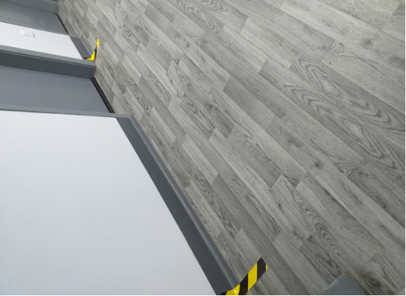
Walk on the left on all corridors at all times. There will be a one way system in operation at identified pinch points. Students should not go up the tower block.
Entrance to the English corridor will be via the main schoolhall/door behind the stage and up the English stairwell by room 9. Exit to the English department will be via the new wide stairwell and new double doors onto the yard. These one way systems will be in operation at all times.

What does my child need to bring?
Your child only needs to bring a calculator, snack and drink. They will be given other equipment and this will be kept in a plastic pouch on their desk and will be for their use only. Students can bring their own antibacterial gel, but the advice is that handwashing with soap and water for at least 20 seconds is the most effective way of keeping virus free.
Behaviour policy
- Students should not leave their seats or the classroom until the lesson has finished or instructed to do by their teachers
- Students with medical conditions who need to leave the classroom will be allowed to do so at the discretion of the teacher. Students who leave the lesson for medical reasons should move straight to first aid, wait outside, call for attention and await guidance.
- Students should avoid all physical contact in school and on the way to and from school… No hugs, shaking hands etc…
- When in the classroom students should sit in the same place at all times and not move from this place unless instructed to do so by the teacher. They will be given a plastic pouch to keep their items in.
- Students must maintain a safe distance from others between and during their lesson
- Students should not share belongings with each other (stationery, food etc…)
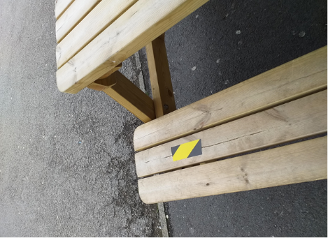
- Students follow the same behaviour expectations and the same behaviour protocols will be in place as normal
- Students must not go to an area of school where they are not scheduled. This would compromise the effectiveness of sanitising schedule and puts others at risk.
- We don’t expect mobile phones to be seen or used whilst in school. If a student has to be repeatedly reminded to put their phone away, parents/carers will be called to come and confiscate the phone. (teachers will not confiscate items to avoid cross contamination.)
- Due to the severe consequences of spitting/coughing/sneezing on someone our behaviour policy has been adjusted to rank this being worthy of the most severe sanction including the possibility of permanent exclusion.
- Zero tolerance towards chewing gum. There will be a vigilance to prevent students from using chewing gum. Removing gum increases risk of spreading infection.

Break times
Break times will be staggered. Students will be escorted to a breakout area and will be asked to walk 2m apart on the left side of the corridor. They will be taken outside and asked to maintain social distancing whilst talking to each other. They will only be able to spent time with their ‘safety cocoon’ and will be told to socially distance.
Illness
Please monitor your child’s health and DO NOT send into school if they are unwell or if they display any COVID 19 symptoms. Any student or adult with an NHS shielding certificate must NOT come into school. Any students or adult who has a condition listed in the clinically vulnerable list should also stay at home if possible.
If a student or a member of their household becomes ill with COVID19 symptoms – they must not come into school.
In line with government guidance staff and students in all settings will be eligible for testing if they become ill with coronavirus symptoms as will members of their household.
Actions if a student shows COVID-19 symptoms:
- Isolate in school
- Inform parents
- Send student home and advise they self-isolate for 7 days and the household self isolates for 14 days
- Encourage student to get tested
- If test is negative – return to school and household ends self-isolation
- If test is positive moved to confirmed case scenario.
Actions if a member of staff shows COVID-19 symptoms:
- Send home immediately
- Inform HR before leave the site
- Advise they self-isolate for 7 days and the household self isolates for 14 days
- Organise a test for the member of staff with their permission
- If test is negative – return to school and household ends self-isolation
- If test is positive moved to confirmed case scenario.
Actions if there is a confirmed case of COVID-19 in the school
- Student or staff member tests positive for COVID-19
- Individual receives medical advice and/or treatment
- Class or group teacher/student was in contact with (The safety cocoon) sent home and told to self-isolate for 14 days. Investigate whether the whole bubble (all students/staff in school/on transport on the specific day) need to isolate.
- Contact Public Health England (PHE) who will investigate and advise.
If further cases are detected within the school again we will contact PHE who will investigate and advise.
What is the arrangement for children of Keyworkers and vulnerable students?
These students will be supervised in school by prior arrangement in the same way as from the beginning of lockdown. We have limited capacity on Monday to Thursday so we will liaise with families about a flexible approach – e.g. break up the working week by coming in on specific days if appropriate. Year 10 can’t mix with this group at any time.
What will students need to wear?
- Students will be required to come to school in their PE kit (or shirt, skirt/trousers – no tie or blazer) so that it can be easily washed as soon as they return home. If they wish to wear a coat they need to bring a plastic bag to store it in during the day.
- Should my child wear a face mask? This is a matter of personal preference. Please note that if a child touches their face to adjust it, there is a higher chance of spreading infection. Also, as moisture builds up throughout the day the student is at greater risk of attracting infection. If a child continues to touch the mask we will ask them to take it off for their own protection.
What lessons will students receive?
To keep the risk of cross infection to a minimum, students will have four lessons on the day that they are in and teachers will come to the room the students are already in, following a sanitisation of the teacher area. The lessons will be English, Maths, Science and RE potentially introducing history, geography, French or Spanish later. All other subjects will be taught online as part of home learning. This will supplement home learning and not replace it. The groupings will be driven by which humanity and language subject the student has opted for, so groups and teachers will not necessarily be the usual ones. Unfortunately, we can’t make any concessions to keep friendships group together. The risk involved in bringing students together for education means that have to reduce the possibility for students to get close. Teachers will remain at the front of the room behind a marker indicating a 2m distance from the front desks.
Cleaning and hygiene
Welfare staff will be on duty throughout the day, sanitising public areas. Students will be asked to wash their hands every time they enter or leave a room. All areas used will be sanitised before each day. Students may wish to use anti bacteria gel but the safest way to wash hands is following PHE advice and washing hands for 20 seconds with soap using a tap. Posters in the wash areas demonstrate this pictorially.
Lunch and snacks
No lunch will be provided but free school meal supermarket vouchers will continue to be provided for those who are eligible. Students must bring a snack/drink in a plastic carrier bag but must keep these with them during the day. We will not be able to provide refrigeration facilities due to infection risk and unfortunately our water fountains will be out of use.
Can parents/carers visit school?
Please do not enter the reception unannounced. In the first instance we ask that you call the office before coming on site. It might be that we can answer your query without increasing the risk of visitors bringing potential infection on site. We will of course make arrangements to see anyone face to face if appropriate, with the necessary precautions.
What is the provision for other year groups?
For Year 7-9 work will continue to be set on epraise with video lessons and ‘zoom type Q&A sessions’ used where appropriate. We are aware that there is not a ‘one size fits all’ due to lots of reasons; home circumstances, the curriculum area, the nature of the subject, access to technology etc. so we are looking at variety of methods that can continue to improve our Learning and Teaching offer at St Joseph’s. If any student is struggling please contact your class teacher via epraise messenger so that we can make arrangements to help better meet your needs.

Mr T McCabe

