Dear Parents and Carers
As we draw towards the end of this year I would like to firstly to thank you for your support throughout the year in the trying circumstances we have found ourselves in.
I am writing to inform you of our uniform policy for the next academic year to ensure students arrive back in September in the correct uniform. There will be no changes to uniform for any students in September as we are mindful that during this time there may be challenges facing families. If you require additional help please contact us and we will offer any assistance we are able.
In a slight change to the policy we have consulted with our current Year 10 students and Governors have agreed that there may be an adaptation to the Policy from January 2022. This change is that a school Leaver’s hoody may be purchased through school and worn instead of a blazer. They will still however be required to wear a shirt and tie. Further details regarding the hoody will be provided next term. This means that in September Year 10 will return in the same uniform they finish school in July and there is no requirement to purchase any new items. Should you wish to purchase a grey jumper for wear during the Autumn term these are still available although there is no requirement to do so and the optional blue jumper is still acceptable.
I would like to take this opportunity to draw your attention to our policy on piercings which does not permit any visible piercings due to the risk of injury and also that on fake tan and false nails which are not permitted.

Please note that our suppliers have been instructed to refuse sale of skirts failing to reach the knee. If all students wear their uniform as designed there will be no peer pressure to flaunt the rules. Please note that our uniform providers can provide different waist sizes for different lengths of skirt meaning that a small waist doesn’t need to equate to a short skirt. Our provider have different services so it might be worth ringing round to check they can supply what you need.

Should students return to school in uniform that does not meet our policy including the wearing of trainers that are unable to be polished or have visible coloured logos we will be in the position of asking that these are replaced. Please consider this when making your purchases as we are aware uniform can be expensive and would prefer not to add to any financial burdens.

Each supplier has provided information regarding their requirements to allow safe opening during this time bearing in mind they will need to restrict the numbers of customers in their shops at particular times. Please contact them individually if you require further information.

September 2021 Uniform
- Dark blue embroidered blazer
- White shirt/blouse
- Tie (Y7 – Y11)
- Black pleated skirt with logo on hip or Trousers – (plain black, not skinny style or jean cut)
- Socks – black ankle or knee length
- Shoes – plain black sensible - (no coloured logos, stripes or fabric. We are defining a shoe as something you can put black polish on and the ankle is uncovered – please see examples below)
- A plain waterproof coat (this can be any colour so long as it is plain – please consider road safety for dark mornings/nights

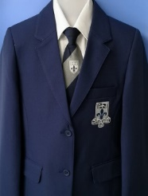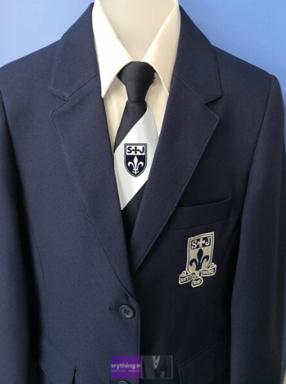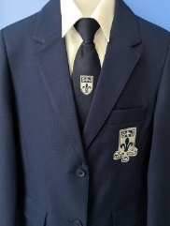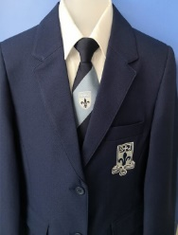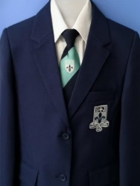
Pale grey stripe – Y7 White Stripe –Y8 Navy tie – Y9 Pale blue stripe – Y10 Aqua stripe – Y11
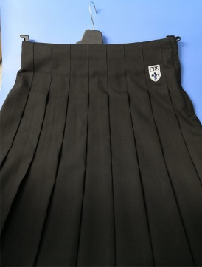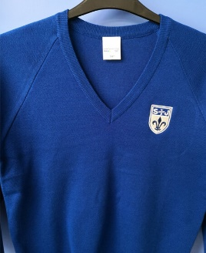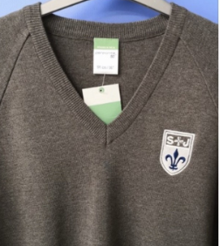

Optional Item
- Royal blue jumper, to be worn under blazer and with tie, Y7 – Y10. This item is non-compulsory to keep the cost of the uniform down should you wish to.
- Grey jumper, to be worn under blazer and with tie, Y11 only. This item is non-compulsory to keep the cost of the uniform down should you wish to.

PE kit:
- Embroidered Black PE shorts or track bottoms or leggings
- Embroidered Black PE T-Shirt

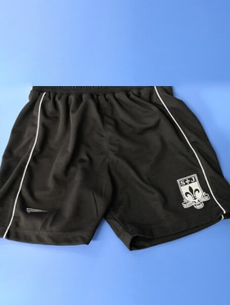 or 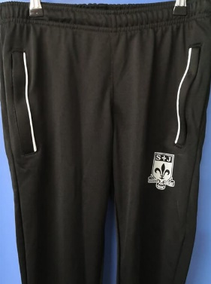 or 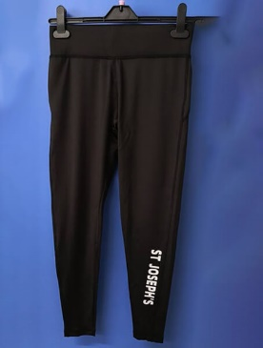 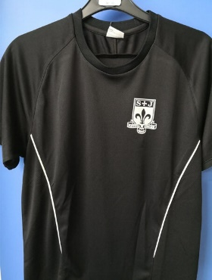
Optional Items
Black ¾ zipped jacket or Black zipped jacket
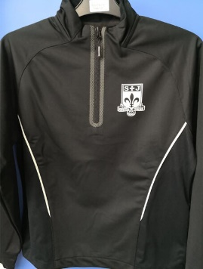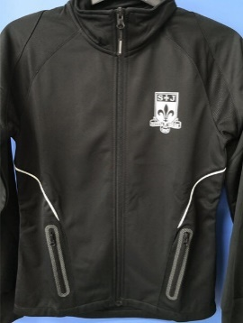

Please note the following when considering footwear…

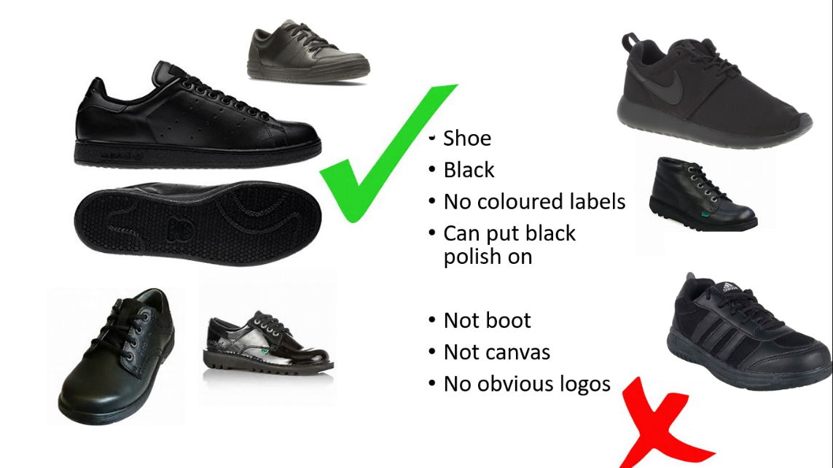

Please also note: Students must not wear nail varnish or false nails, jewellery, hoodies, track tops or have any visible piercings (Nose, ear or tongue)
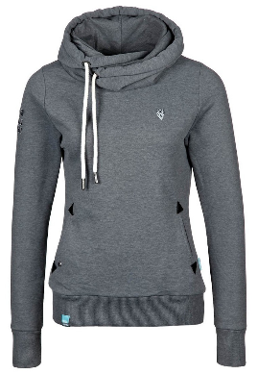

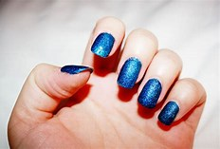
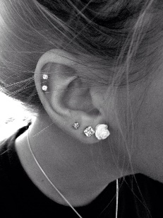

Our Suppliers:
Contract Schoolwear (01204) 62464
Andrew Leach’s Schoolwear Horwich (01204) 697624 http://www.andrewleachschoolwear.co.uk/
Whittakers Schoolwear, Bolton (01204) 389485 www.whittakersschoolwear.co.uk
Aspull Village Embroidery, Aspull (01942) 830153https://www.aspullvillageembroidery.co.uk/stjosephs/

I would like to take this opportunity to thank you for your continuing support. Uniform is monitored daily and currently almost 100% of St Joseph's pupils turn up in the correct uniform. This is a huge support and enables us to focus on our core purpose of Learning & Teaching and, ultimately on your child's on-going success.

Yours sincerely

Mrs N Yorke-Robinson

Deputy Headteacher

Arrangements from our Suppliers during the current Pandemic

We have been warned there may be possible shortages in the supply chain due to the pandemic and the issues in the Suez Canal earlier this year so politely suggest you make any purchases early if possible.

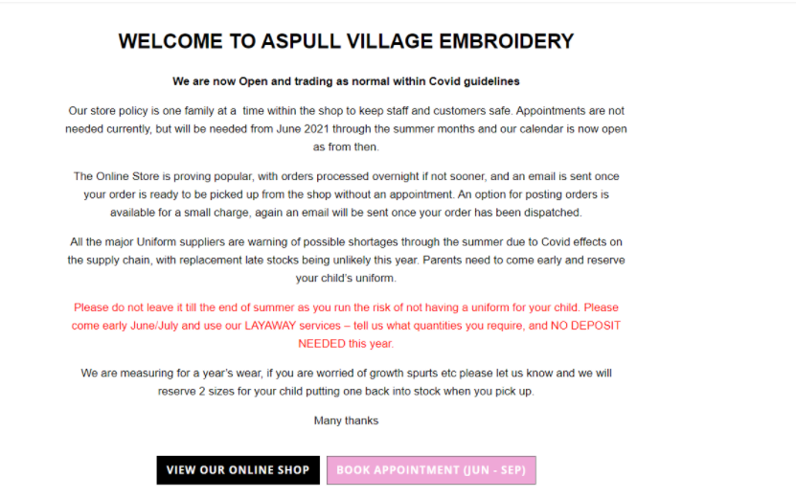
ANDREW LEACH SCHOOLWEAR
HAVE MOVED TO 98 WINTER HEY LANE, HORWICH BOLTON LANCASHIRE BL6 7PJ
THE PHONE NUMBER & CONTACT EMAIL DETAILS REMAIN THE SAME
01204 697624 andrewleach@gmx.com www.andrewleachschoolwear.co.uk
PLEASE NOTE : NO APPOINTMENTS ARE NEEDED TO VISIT THE SHOP WE ARE JUST LIMITING THE AMOUNT OF CUSTOMERS IN THE SHOP AT ANY ONE TIME.
WE LOOK FORWARD TO SEEING YOU SOON.
IF YOU NEED ANYMORE INFORMATION PLEASE DO NOT HESITATE TO CONTACT US.
RACHEL EDWARDS
BUSINESS OWNER
