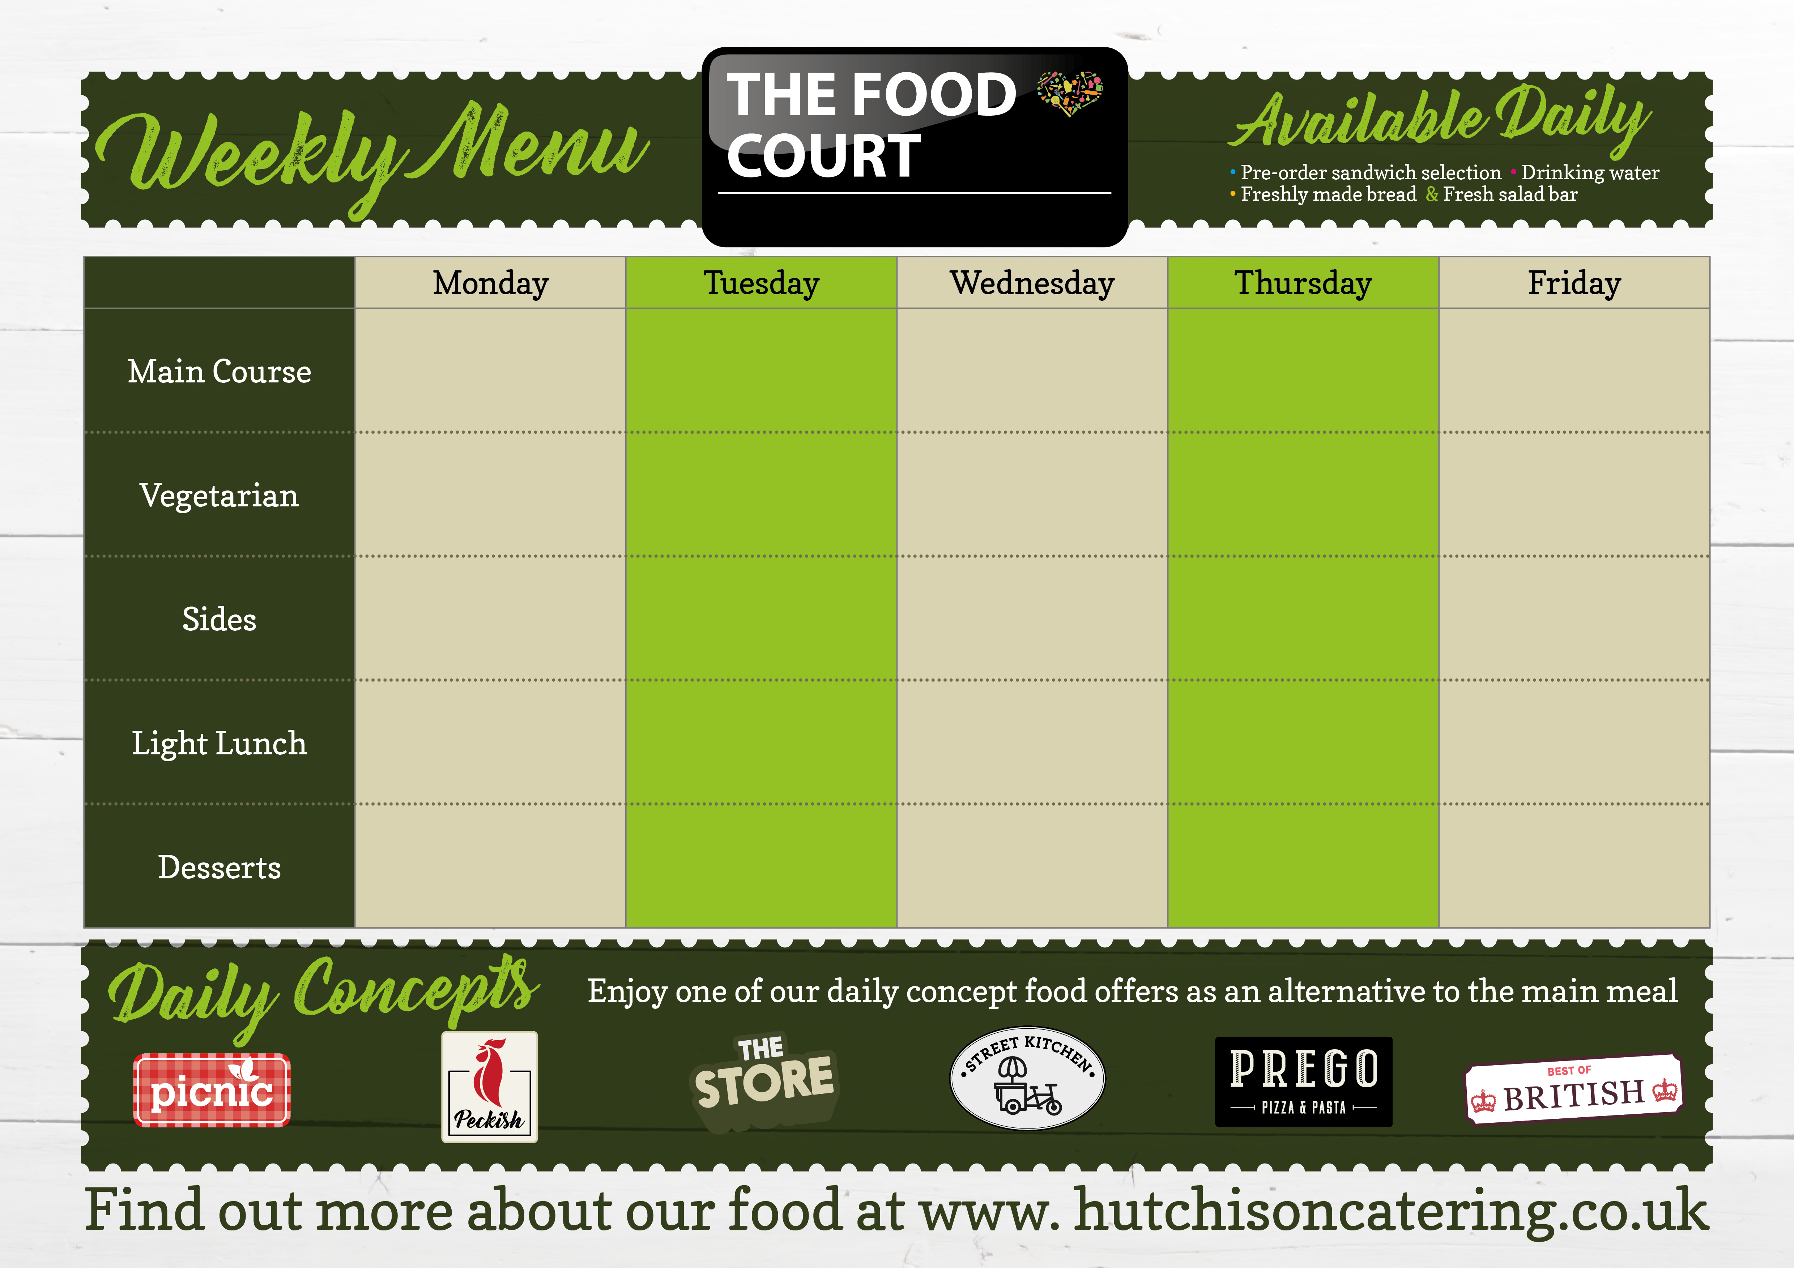

**Assorted Cold Sweets**

Cookies, Brownies, Flapjacks, Angel Delight, Jelly Pots

Margherita Pizza

Jacket Potato

Beans

Garlic Bread

**Tomato and Basil Pasta** with Garlic Bread

**Italian Meatballs with Pasta** and Garlic Bread

**Chicken Tandoori Wrap with Wedges**

Jacket Potato

Beans

Curry Sauce

Zinger Chicken Burger

**Assorted Cold Sweets**

Cookies, Brownies, Flapjacks, Angel Delight, Jelly Pots

**MERRY CHRISTMAS FROM ALL THE STAFF AT HUTCHISON CATERING!!**

A joyous Festive Bunch of Assorted Delights to get into the Christmas Spirit!

**Brunch!**