24th February 2022

**Dear Parents and Carers**

We are pleased to say we have far fewer cases of Covid in young people at school than we did last term. Overall case numbers have continued to fall in Bolton although they are not yet low.  The current rate of new positive cases amongst children aged 5-9 is currently 94 per 100,000 and for 10-14s is 196 per 100,000. The reduction in rate is largely due to the effectiveness of the vaccine. Thank you too all those who supported our school age roll out. If any of your family missed either first, second or third of fourth booster vaccines, you can book using the following link: [Book or manage a coronavirus (COVID-19) vaccination - NHS (www.nhs.uk)](https://www.nhs.uk/conditions/coronavirus-covid-19/coronavirus-vaccination/book-coronavirus-vaccination/)

You will be aware that on Tuesday, the Prime Minister set out the next phase of the government’s Covid-19 response, [‘Living with Covid-19’](https://ascl.us7.list-manage.com/track/click?u=dae6fbf66d6135a8a21b3627d&id=d55fd96c9f&e=26a184143d). Here is a summary of the key points:

**Self-isolation**

* From Thursday 24 February, the government will remove the *legal requirement* to self-isolate following a positive test. However, adults and children who test positive will continue to be *advised* to stay at home and avoid contact with other people for at least five full days, and then continue to follow the guidance until they have received two negative test results on consecutive days. We would like to encourage parents and carers in our community to follow this advice.
* Routine contact tracing will end. Fully vaccinated close contacts and those aged under 18 will no longer be asked to test daily for seven days, and close contacts who are not fully vaccinated will no longer be required to self-isolate.
* More details can be found in the [Living with Covid-19](https://ascl.us7.list-manage.com/track/click?u=dae6fbf66d6135a8a21b3627d&id=4e7a4ae54d&e=26a184143d) plan.

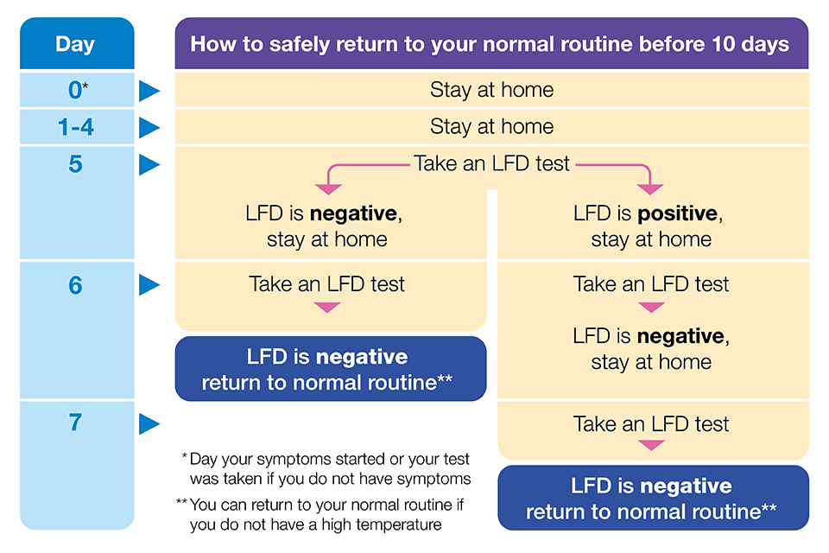

**Testing**

With immediate effect, the government has removed the guidance for staff and students in most education and childcare settings to undertake twice-weekly asymptomatic testing. We will continue to report cases to our local public health teams and as with previous announcements a decision to implement additional measures could be recommended by our local Health Protection Team if we experience a surge in cases. We will be able to order further LfD tests in the case of an outbreak but all staff and students will continue to be able to access test kits from their local pharmacy or [online](https://ascl.us7.list-manage.com/track/click?u=dae6fbf66d6135a8a21b3627d&id=7d7bc0bb2f&e=26a184143d).

**Face coverings**

Face coverings may be worn but this is personal choice and is now no longer mandatory at St Joseph’s. We will continue to support those who wish to wear one and we will monitor the situation and work with our local health protection team so that if the situation changes we are ready to re-implement measures.

**Uniform**

Now that our focus doesn’t need to be on checking for face coverings, we will be asking all form tutors to do a daily equipment and uniform check. Please make sure that your child has removed all jewellery, hoodies (except permitted Y11 hoodies) and that skirts are worn to the knee before leaving from home. Please ask them to wear their blazer. Coats may be worn over the blazer or plain base layers under their shirt but hoodies will have to be confiscated as we try to create consistency.  
  
  
**Equipment**   
Please make sure that your child has their full PE kit with them on PE days. We also expect them to have a black pen, purple pen, ruler, pencil and eraser with them. We advise having coloured pencils and highlighter to help their independent study and of course to bring their exercise books for the day. If your child has lost any equipment please remind them that they can purchase more using Epraise points from the Epraise shop.  
  
  
**Punctuality**  
We understand that traveling by bus might often result in a child being late from school, but more often than not, it is those who come by car or walk to school who are most frequently late. We are monitoring this and will be asking that students set out 15 minutes earlier if this continues. We have also been doing ‘corridor sweeps’ 5 minutes after lesson bells and speaking to students who have wasted lesson time dawdling to class. The start of the lesson is really important as previous learning is recapped and the scene is set for the new learning. Please encourage your child to take a mature approach to this. Being four minutes late to every lesson all year is the equivalent of missing a fortnight of school.

**Thankyou**

May I take this opportunity to thank all parents and carers who have been so supportive as we have navigated the unchartered territory of the whole pandemic during the past two years. Your patience and support has made the hard task much more manageable. Covid isn’t yet behind us and I know that it has left its bruises and scars in our lives, but together we have got to this better place in time. We look forward to working with you to continue in the adventure of learning.