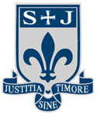
St Joseph’s Roman
Catholic High School

Uniform Policy

Jesus Christ is our family role model
Opening our hearts and minds to dream the impossible and achieve beyond our wildest imagination
Everybody is valued and respected
Young and old will journey together to build God’s Kingdom.
Striving for academic excellence and celebrating success in all we do

Approved by Governors: February 2023
Review Date: February 2024
Contents
1. Aims ………… ……………………………………………………………………………………………2
2. Our school's legal duties under the Equality Act 2010 ………….………………………….2
3. Limiting the cost of school uniform…………………………………………………………………3
4. Expectations of school uniform……………………………………………………………………4-6
5. Expectations for our community…………………………………...…………………………….7-8
6. Monitoring arrangements………………………………………………………………………………8
7. Links to other policies……………………...…………………………………………………………..8

1. Aims
This policy aims to:
- Set out our approach to requiring a uniform that is of reasonable cost and offers the best value for money for parents and carers
- Explain how we will avoid discrimination in line with our legal duties under the Equality Act 2010
- Clarify our expectations for school uniform

2. Our school’s legal duties under the Equality Act 2010
The Equality Act 2010 prohibits discrimination against an individual based on the protected characteristics, which include sex, race, religion or belief, and gender reassignment.
To avoid discrimination, our school will:
- Avoid listing uniform items based on gender, to give all students the opportunity to wear the uniform they feel most comfortable in or that most reflects their self-identified gender
- Make sure that our uniform costs the same for all students
- Allow all students to have long hair (though we reserve the right to ask for this to be tied back)
- Allow all students to style their hair in the way that is appropriate for school yet makes them feel most comfortable
- Allow students to request changes to swimwear for religious reasons
- Allow pupils to wear headscarves and other religious or cultural symbols
- Allow for adaptations to our policy on the grounds of equality by asking students or their parents to get in touch with Mrs Yorke-Robinson- Deputy Headteacher who can answer questions about the policy and respond to any requests

3. Limiting the cost of school uniform
Our school has a duty to make sure that the uniform we require is affordable, in line with statutory guidance from the Department for Education on the cost of school uniform.
We understand that items with distinctive characteristics (such as branded items, or items that have to have a school logo or a unique fabric/colour/design) cannot be purchased from a wide range of retailers and that requiring many such items limits parents’ ability to ‘shop around’ for a low price.
We will make sure our uniform:
- Is available at a reasonable cost
- Provides the best value for money for parents/carers
We will do this by:
- Carefully considering whether any items with distinctive characteristics are necessary
- Limiting any items with distinctive characteristics where possible e.g. Blazer
- Limiting items with distinctive characteristics to low-cost or long-lasting items, such as ties
- Considering cheaper alternatives to school-branded items as long as this doesn’t compromise quality and durability
- Avoiding specific requirements for items pupils could wear on non-school days, such as coats, bags and shoes
- Keeping the number of optional branded items to a minimum, so that the school’s uniform can act as a social leveler
- Avoiding different uniform requirements for different year/class/house groups
- Avoiding different uniform requirements for extra-curricular activities except where necessary e.g.PE
- Considering alternative methods for signaling differences in groups for interschool competitions, such as creating posters or labels
- Making sure that arrangements are in place for parents to acquire second-hand uniform items
- Avoiding frequent changes to uniform specifications and minimising the financial impact on parents of any changes
- Consulting with parents and pupils on any proposed significant changes to the uniform policy and carefully considering any complaints about the policy

4. Expectations for school uniform
4.1 Our school’s uniform

Compulsory Items
- Dark blue embroidered blazer
- White shirt/blouse (non-branded)
- Tie (Y7 – Y11)
- Black pleated skirt with logo on hip or non –branded trousers – (plain black, not skinny style or jean cut)
- Socks – plain black ankle or knee length (no logos must be visible)
- Shoes – plain black sensible - (no coloured logos, stripes or fabric. We are defining a shoe as something you can put black polish on and the ankle is uncovered – please see examples below)
- A plain waterproof coat (this can be any colour so long as it is plain – please consider road safety for dark mornings/nights

Pale blue stripe – Y7 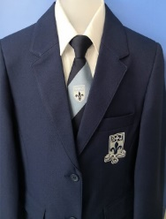 | 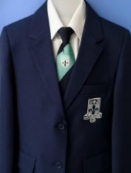  Aqua stripe – Y8 | Pale grey stripe – Y9  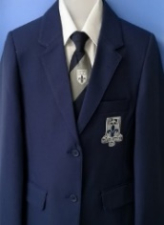 | White Stripe –Y10 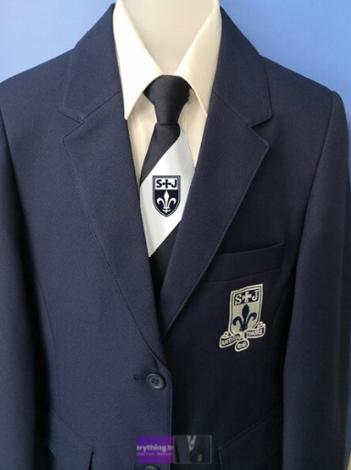 | Navy tie – Y11  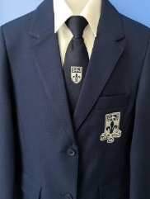

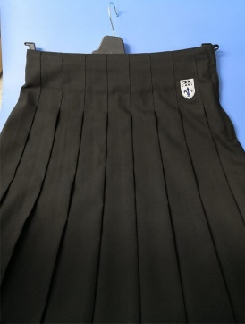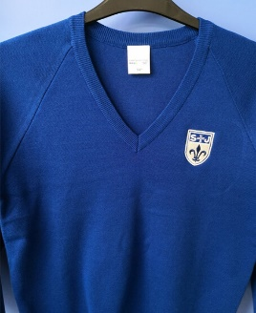

Optional Item (branded)
- Royal blue jumper, to be worn under blazer and with tie, Y7 – Y10. This item is non-compulsory to keep the cost of the uniform down if you wish to.
Please note that our suppliers have all worked with us and they have been instructed to refuse sale of skirts failing to reach the knee. If all students wear their uniform as designed there will be no peer pressure to flaunt the rules.

PE kit:
- Embroidered Black PE shorts or track bottoms or leggings
- Embroidered Black PE T-Shirt

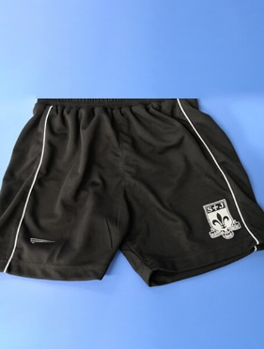 or 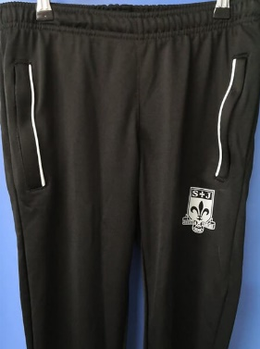 or 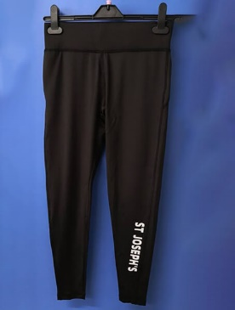 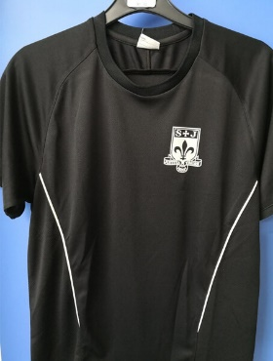
Optional Items
Black ¾ zipped jacket or Black zipped jacket
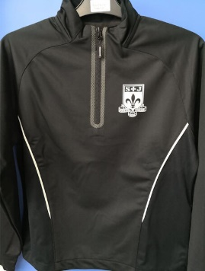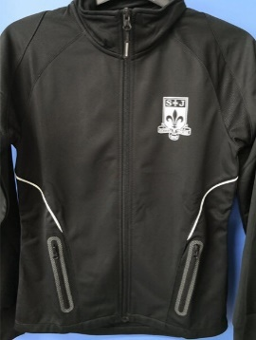
Please note the following when considering footwear…

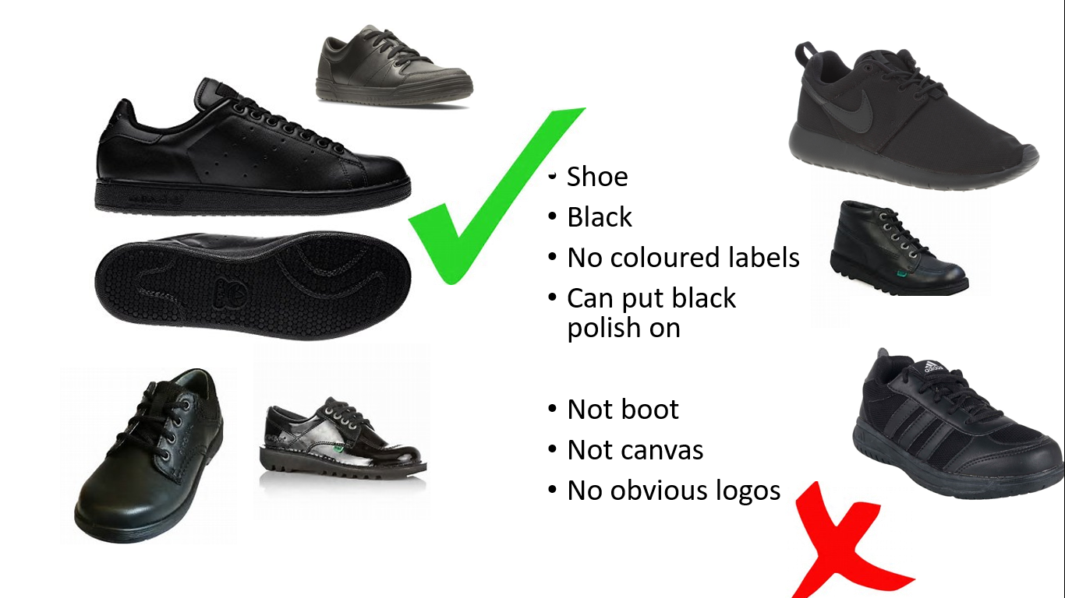

Students are not permitted to wear jewellery (unless it has been approved as with health and safety consideration and is considered inclusive to faith and cultures) excepting a wrist watch (this will need to be removed during examinations as per examination board guidelines). Hair must be of one natural colour (we define a natural hair colour as one a person may be born with) and should not be of an extreme nature including the addition of lines or patterns (we define an extreme nature as a number 2 or less all over).
Students wishing to cover their heads on religious or cultural grounds may do so using a black or navy blue head scarf or durag. Other headwear is not permitted unless prior arrangement due to medical grounds.
False nails and false eye lashes are not permitted unless prior permission is obtained. We are mindful of that some students may feel the need to use small amounts of make up as a cover up to teenage acne etc., we reserve the right to ask students to remove any excessive amounts of make-up worn.
We remind students that on non-uniform days and when attending school activities that school is a place of work and appropriate attire should be worn. There is no expectation that new clothes should be purchased for the any event
4.2 Where to purchase it

Our items of branded uniform can be purchased from the suppliers below. Other items e.g. shirts and trousers may be purchased from any high street store.

Andrew Leach’s Schoolwear Horwich (01204) 697624 http://www.andrewleachschoolwear.co.uk/

Whittakers Schoolwear, Bolton (01204) 389485 www.whittakersschoolwear.co.uk

Aspull Village Embroidery, Aspull (01942) 830153 https://www.aspullvillageembroidery.co.uk/stjosephs/

We have teamed up with Community Locker to help make it easy for parents and carers to recycle and purchase as good as new items on a budget. More information can be found at facebook@breightnmetcommunitygroup

Alternatively, just contact school or if you have old preloved uniform please let us know and we can make sure that those in school who need it most benefit.

5. Expectations for our school community
5.1 Students
Students are expected to wear the correct uniform at all times (other than specified non-school uniform days) while:
- On the school premises
- Travelling to and from school
- At out-of-school events or on trips that are organised by the school, or where they are representing the school (if required)
Pupils are also expected to contact Mrs Yorke-Robinson or their Head of Year if they want to request an amendment to the uniform policy in relation to their protected characteristics.
5.2 Parents and carers
Parents and carers are expected to make sure their child has the correct uniform and PE kit, and that every item is:
- Clean
- Clearly labelled with the child’s name
- In good condition
Parents are also expected to contact Mrs Yorke-Robinson or their Head of Year if they want to request an amendment to the uniform policy in relation to:
- Their child’s protected characteristics
- The cost of the uniform
Parents are expected to lodge any complaints or objections relating to the school uniform in a timely and reasonable manner.
Disputes about the cost of the school uniform will be:
- Resolved locally
- Dealt with in accordance with our school’s complaints policy
The school will work closely with parents to arrive at a mutually acceptable outcome.
5.3 Staff
Staff will closely monitor pupils to make sure they are in correct uniform. They will give any students and families breaching the uniform policy the opportunity to comply, but will follow up with the headteacher if the situation doesn’t improve.
Ongoing breaches of our uniform policy will be dealt with following our school behaviour policy.
In cases where it is suspected that financial hardship has resulted in a student not complying with this uniform policy, staff will take a mindful and considerate approach to resolving the situation.
5.4 Governors
The governing board will review this policy and make sure that it:
- Is appropriate for our school’s context
- Is implemented fairly across the school
- Takes into account the views of parents and pupils
- Offers a uniform that is appropriate, practical and safe for all pupils
The board will also make sure that the school’s uniform supplier arrangements give the highest priority to cost and value for money, for example by avoiding single supplier contracts and by re-tendering contracts at least every 5 years.

6. Monitoring arrangements
This policy will be reviewed on an annual basis by Mrs Yorke-Robinson Deputy Headteacher]. At every review, it will be approved by Student Support Committee.

7. Links to other policies
This policy is linked to our:
- Behaviour policy
- Equality information and objectives statement
- Anti-bullying policy
- Complaints policy

