

St Joseph’s

Roman Catholic

High School

Exams Handbook 2024

A guide to written exam arrangements for students and parents/carers

**J**esus Christ is our family role model

**O**pening our hearts and minds to dream the impossible and achieve beyond our wildest imagination

**E**verybody is valued and respected

**Y**oung and old will journey together to build God’s Kingdom

**S**triving for academic excellence and celebrating success in all we do

**Introduction**

At St Joseph’s we are committed to ensuring that candidates are fully briefed on the exam and assessment process in the centre and are made aware of the required JCQ/awarding body instructions and information for candidates.

We aim to make the exam experience as stress-free and successful as possible for you. Hopefully this booklet will provide answers to questions you may have about the exams you will be sitting with us.

Please read this booklet carefully so that you are aware of how things should happen before, during and after the exams. The awarding bodies (exam boards) have a strict set of rules and regulations that we have to make sure you follow. These are at the end of this booklet, along with a list of frequently asked questions that may be useful to you.

If you have any queries or need any advice before, during or after the exams please contact:

Exams Manager – Mrs R Holmes

01204 697456

[rholmes@st-josephs.bolton.sch.uk](mailto:rholmes@st-josephs.bolton.sch.uk)

Room A30, also known as the Epraise shop

**General information**

**Exam entries**

You will receive a statement of entry, shortly after the February half-term, telling you which exams you have been entered for. Please keep this safe and make sure you check the information shown. It will tell you what dates and times your written exams are, what tier you are entered for. If it says anything different than you expect please contact, your class teacher or Mrs Holmes, the Exams Manager, as soon as possible.

**Awarding bodies**

St Joseph’s uses the following awarding bodies for GCSE/CNAT/BTEC exams:

AQA, WJEC, Pearson (Edexcel), and OCR.

**Candidate name**

For all qualifications your **legal** name will be used. This is the name that is shown on your birth certificate (or deed poll document if you’ve ever changed your name).

**Contact numbers**

Please make sure that school has at least one up to date contact number for you.

**Equipment**

You need to bring your own equipment to the exams. Pencil cases should be clear plastic and pens should have black ink. You may also need a pencil, eraser, ruler, sharpener, protractor, compass and (scientific) calculator.

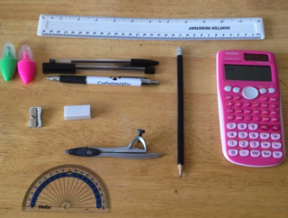Highlighters may be useful in highlighting important parts of the question but they are not allowed in your answers.

**Exam Clashes**

If you have an exam clash where 2 exams in different subjects are timetabled to occur at the same time you will be contacted by the Exams Manager who will tell you what arrangements will take place.

**Exam Contingency Day**

Wednesday the 26th of June is the contingency day for 2024. You must make sure you are available up to and including this date.

**Exam regulations**

A copy of the ‘Exam Room Rules’ that goes through the regulations set by the awarding bodies is available at the end of this handbook.

j0234131 **Exam information**

**Start times for exams**

Unless we tell you otherwise these are the start times for exams:

Morning: **8:30am**

Afternoon: **1.00pm**

If you are later than 10am for a morning exam, or 2.30pm for an afternoon exam, the awarding body might not accept your work.

**Exam Rooms**

The majority of pupils will sit their exams in the Sports Hall, but we also use St Anthony’s and the Chapel. Your exam room will be on your timetable, along with your seat number. If you forget where you are sitting there will be a copy of the seating plan on the noticeboard on the outside wall of the Sports Hall. The Exams Manager/invigilators will also have a copy of the seating plan and will help you to find your seat.

**Attendance at exams**

You are responsible for making sure you attend school on time for each of your exams. If you are unable to attend for any reason please contact school as soon as possible on the morning of your exam.



**Malpractice**

• Do not try to talk to any other learners in the exam.

• Do not distract any other learners in the exam.

• Do not take any unauthorised items into the exam (listed in the rules and Appendix 1).

Mobile phones must not be on you (e.g. in your pocket) in the exam. You must switch any mobile phones off and place them in the box at the front of your row. If you are found to have one on you in the exam we have to report it to the awarding body, who will give you zero marks

If you are found with your phone on you (switched **off**) during an exam you will be awarded no marks for the exam paper you are in at the time.

If you are found with your phone on you (switched **on**) during an exam you will be awarded no marks for the whole subject you are in at the time.

In controlled assessments:

• Do not copy or allow your coursework/NEA work, if appropriate, to be copied

• Do not allow others to help produce your coursework/NEA work or help them with theirs.

**Exam Pointers**

Exam regulations start the moment you enter the exam room. You must be silent from this moment on until you leave the exam room.

Read and follow the instructions on the front of the question paper

Listen carefully to all instructions when you are in the exam room. There may be things you need to know about that are not already written on your paper.

Fill in your details in capital letters as the paper tells you to **— make sure you use your legal name, not a preferred name.**

Write your answers in the sections of the paper/answer booklet as the instructions say. If you are using an answer booklet make sure you label your answers clearly. Remember to hand in any rough work. Add your details to any extra answer sheets that you use and make sure you hand them in.

If you finish the exam early use the rest of your time to check through the paper in case you think of things to add to your answers.

Your exam paper will be collected by the invigilators before you leave the exam room. You should stay silent while you are in the room unless you need to speak to an invigilator.

Make sure you leave all stationery you have been given for the exam in the exam room.

**Can I go to the toilet during the exam?**

If you are desperate you can go to the toilet, but you will need to be taken by one of the invigilators. You will not be allowed to add on any time at the end of the exam that you have lost by being out of the room.

**How do I know how long each exam is?**

The length of each exam is shown on the board in the exam room. It will also be on the front of your paper. The invigilator will write on the board what time the exam is due to finish and there will be a clock in the exam room. A 5 minute warning will be given before the end of the examination.

**Results information**

**Being notified of exam results**

Results will be available for collection on results release day in August. You will be given a letter that tells you what date results day is and the time to attend.

Senior members of staff will be available for you to speak to on results day along with the Exams Manager.

If you want someone to collect your results, you must inform school beforehand and your nominated person must bring a signed letter confirming you have given permission. Uncollected results will be posted home, but they could take a few days to arrive.

 Exam results are **NOT** sent via email and they will never be given out over the phone.

**Enquiries about results (EAR)**

If you think there has been a problem with your results please speak to either your class teacher or the Exams Manager (if your teacher is not available) and they will be able to advise you on what you should do.

The post results services offered are; - a review of results, appeals and access to scripts.

Requests for post-results services must be made through St Joseph’s, not directly with the exam board.

You will be informed of deadlines, fees and other charges for these services on results day. Written consent must be provided.

**Collecting certificates**

We usually have a presentation evening, in November, where the certificates for all qualifications you have achieved will be presented to you. The results day letter will tell you when this will be. Further details will be sent out nearer the time to remind you of this event. If you are unable to come to the presentation evening, certificates will be available for collection by yourself or someone acting on your behalf after this event has taken place.

If you lose your certificates you can only get replacement ones from the awarding bodies that issued them to begin with. You will need to apply directly to them, provide proof of identity and pay a fee. To avoid this please collect your certificates and keep them safe. Certificates are retained by the centre for one year after which time they are confidentially destroyed.

**Frequently Asked Questions**

**What do I do if I think I have the wrong paper?**

If you think there is something wrong put your hand up to speak to the invigilator.

**What is the school centre number?**

The centre number is **32159**. This will be displayed in the exam room.

**What do I do if I have an accident or I’m ill before an exam?**

Contact school as soon as you can so we can advise you what to do. If you are unable to write it may be possible to give you a scribe but we need as much notice as possible and you will need medical evidence from your doctor or hospital if you are ill.

**What is special consideration?**

Special consideration is when marks are adjusted for an exam candidate after an exam has been taken. This is applied for by the school where necessary and where there is good reason. Candidates who are fully prepared for the exam and have attended school regularly for the lessons could be allowed this if something happens around the time of the exam which means that their work on the day is affected (e.g. illness, accident or injury, death of a close relative, crisis at home, etc.). The Exams Manager must be informed straight away of anything that will affect your performance in your exams so that an application for special consideration can be made in time. The centre never finds out if special consideration has been applied only if the application has been accepted.

**What if I feel ill during the exam?**

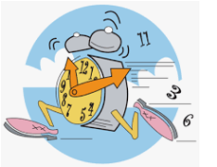Put your hand up to tell the invigilator and they will assist you as needed. You should also tell them if you feel ill as you are going into the exam.

**If I’m late can I sit the exam?**

If you know you are going to be late please inform the school office as soon as you know you’re running late. Depending how late you arrive, you may be able to still sit the exam. If you are very late the awarding body might not accept your work.

**If I miss an exam can I take it on another day?**

No. The awarding bodies set the dates for each exam and you must attend on the date and time they set.

**What can I take into the exam room?**

Only items that are specified on the front of the exam paper. If you take items in to an exam that are not allowed you might be disqualified from that exam paper, and possibly others as well.

Bags and coats are not allowed to be at your desk during an exam – they should be left at the side of the exam room with anything in them that is not allowed in the room.

You are not allowed mobile phones, mp3 players, any watches and any other electronic devices that could store data on them. If you are found with one of these in an exam you will not be given any marks for that paper.

**What happens if my phone rings in an exam?**

We have to tell the exam board and you may be disqualified for the whole of that subject. To avoid this make sure your mobile phone is switched off (including switching off any alarms). Place your mobile phone in the box on the front of your row.

If you are found with your phone on you (switched **off**) during an exam you will be awarded no marks for the exam paper you are in at the time.

If you are found with your phone on you (switched **on**) during an exam you will be awarded no marks for the whole subject you are in at the time.

**What happens if the event of an emergency in the exam room?**

The invigilators will tell you to stop writing and to close your answer booklet. You will then be directed out of the exam room via the nearest exit. You need to line up on the tennis courts in your rows and remain silent.



**Who is the invigilator?**

The invigilator is the member of staff who is supervising you in the exam room. At St Joseph’s we use external invigilators that are trained annually by the Exams Manager, you will have met them when you did your Pre Public exams. The invigilators make sure that you have everything you need to complete the paper. They are not allowed to explain any of the questions to you, advise you which questions to answer or tell you if your work is okay or not.

**Exam Room Rules**

1. Do not be late for your exam. *If you are late your work might not be accepted.*

2. Do not cheat, or let anybody else cheat from your work.

3. If you do cheat you could be disqualified from **all** of your GCSE subjects.

4. Only take allowed items into the exam with you. Any pencil cases must be see-through.

5. You are not allowed to take any notes into the exam room with you. Also you are not allowed to

take any technological devices in, such as iPods, mobile phones, MP3/4 players, electronic storage

equipment, and any other digital equipment that is web enabled. Watches of any kind are not

permitted. ***If you are found with any of these on you, or in your pocket, you could be disqualified***

***even if you are not intending to use it.***

6. Water is allowed in an exam room. Please make sure the bottle is clear and free from labels and

writing.

7. You are not allowed to use correcting pens or fluids/tapes (e.g. tippex), erasable pens, highlighters

or gel pens in any of your ***answers***.

8. You **must not** write inappropriate, obscene or offensive things on your exam paper.

9. Do not try to communicate with or disturb any other candidates in the exam room.

10. If you leave the exam room before the exam has finished you will not be allowed back in unless

you have been supervised all the time.

11. Do not try to borrow anything from someone else sitting the exam while you are doing the exam.

j0234131**Things to Remember**

• Make sure you know the dates and times of all your exams

· Arrive at school at least 15 minutes early for your exams

· If you arrive late you must go straight to the exam room and speak to the person in charge

· If you arrive more than an hour after the exam board’s starting time you might not be allowed to sit

the exam

· Only take what you will need into the exam

· Write in black ink. The front of your paper will tell you what other equipment you are allowed to

use, if you are not sure

**Tell the Invigilator as soon as possible if:**

· You have the wrong exam paper

· There is some equipment that you are allowed but haven’t been given (e.g. Dictionary/thesaurus)

· The question paper is badly printed and you can’t read it

· You have a problem and don’t know what to do

· You are ill

· You need more paper

· You feel like there is any reason that you can’t do your best on the exam day



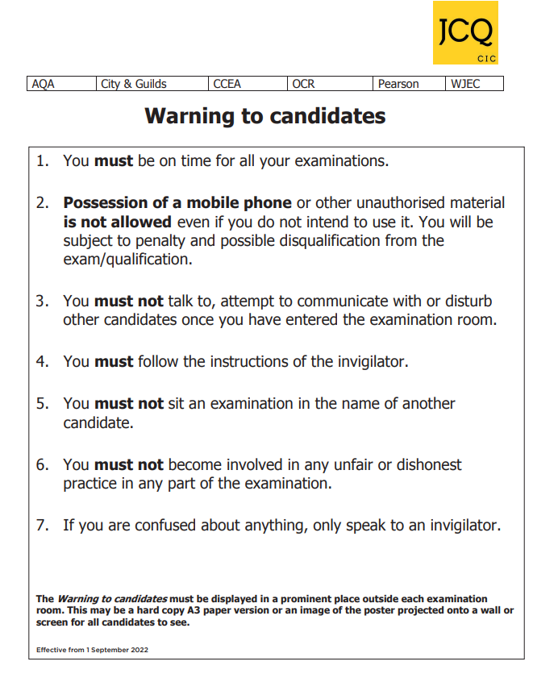



**While we like to share our experiences online, when**

**it comes to exams, we have to be careful.**

Sharing ideas online can be helpful when you’re studying

or revising

• However, sharing certain information can break the rules

and could affect your results

• If you’re not sure what you can and can’t discuss online, check with your teacher

• If you receive exam content on social media, you must tell your teacher

• Don’t be caught out by scammers selling fake exam papers

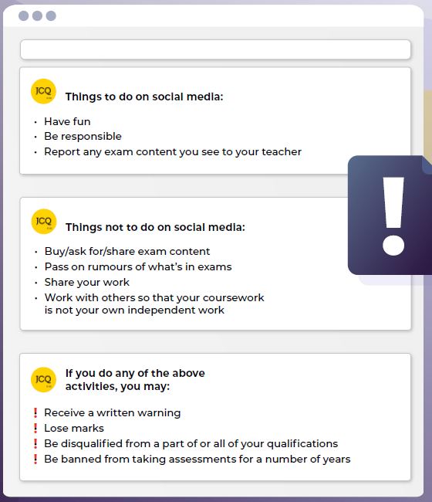



This document has been written to help you. Read it carefully and follow the instructions.



**A. Regulations – Make sure you understand the rules**

**1.** Be on time for all your exams. If you are late your work might not be accepted.

1. **Do not** become involved in any unfair or dishonest practice during the exam.
2. If you try to cheat, or break the rules in any way, you could be disqualified from all your subjects.
3. You **must not** take into the exam room:
4. Notes
5. An iPod, a mobile phone, a MP3/4 player or similar device, a watch, Airpods, earphones/earbuds.

Any pencil cases taken into the exam room **must** be see-through.

**Remember: possession of unauthorised material is breaking the rules, even if you do not intend to use it and you will be subject to penalty and possible disqualification.**

1. If you have a watch, the invigilator will ask you to hand it in.
2. **Do not** use correcting pens, fluid or tape, erasable pens, highlighters or gel pens in your answers.
3. **Do not** talk to or try to communicate with, or disturb other candidates once the exam has started.
4. You must not write inappropriate, obscene or offensive material.
5. If you leave the exam room unaccompanied by an invigilator before the exam has finished, you **will not** be allowed to return.
6. **Do not** borrow anything from another candidate during the exam.

**B. Information – Make sure you attend your exams and bring what you need**

1. Know the dates and times of all your exams. Arrive at least 10 minutes before the start of each exam.
2. If you arrive late for an exam, report to the invigilator running the exam.
3. If you arrive more than 1 hour after the published starting time for the exam, you may not be allowed to take it.
4. Only take into the exam room the pens, pencils, erasers and any other equipment which you need for the exam.
5. You must write clearly and in black ink. Coloured pencils or inks may only be used for diagrams, maps, charts, etc. unless the instructions printed on the front of the question paper state otherwise.

**C. Calculators, dictionaries and computer spell-checkers**

1. You may use a calculator unless you are told otherwise.
2. If you use a calculator:
3. Make sure that it works properly; check that the batteries are working properly;
4. Clear anything stored in it;
5. Remove any parts such as cases, lids or covers which have printed instructions or formulae;
6. **Do not** bring into the exam room any operating instructions or prepared programs,
7. Do not use a dictionary or computer spell checker unless you are told otherwise.

**D. Instructions during the exam**

1. Always listen to the invigilator. Always follow their instructions.
2. Tell the invigilator at once if:
3. You think you have not been given the right question paper or all the materials on the front of the paper;
4. The question paper is incomplete or badly printed.
5. Read carefully and follow the instructions printed on the question paper and/or on the answer booklet.
6. **Do not** start writing anything until the invigilator tells you to fill in all the details required on the front of the question paper and/or the answer booklet before you start the exam. **Do** **not** open the question paper until you are instructed that the exam has begun.
7. Remember to write your answers within the designated sections of the answer booklet.
8. Do your rough work on the proper exam stationery. Cross it through and hand it in with your answers.

Make sure you add your candidate details to any additional answer sheets that you use, including those used for rough work.

**E. Advice and assistance**

1. If on the day of the exam you feel that your work may be affected by ill health or any other reason, tell the invigilator.
2. Put up your hand during the exam if:
3. You have a problem and are in doubt about what you should do;
4. You do not feel well;
5. You need more paper.
6. You **must not** ask for, and will not be given, any explanation of the questions.

**F. At the end of the exam**

1. If you have used more than one answer booklet and/or any supplementary answer sheets, place them in the correct order.

Place any loose additional answer sheets inside your answer booklet. Make sure you add your candidate details to any additional answer sheets that you use.

1. Do not leave the room until you are told to do so by the invigilator.
2. Do not take from the exam room any stationery. This includes the question paper, answer booklets used or unused, rough work or any other materials provided for the exam.



**Information for Candidates**

**Information About You and How We Use It**

You have entered general or vocational qualifications such as GCSE, A-Level, functional skills qualifications etc. with one or more of the awarding bodies listed above. In order to be able to provide examinations and assessments, the awarding body needs to collect and use information about you. This notice provides you with a high level summary of the information the awarding body is required by law to give you about what happens to that information. For more detail see each awarding body’s full Privacy Notice:

AQA <https://www.aqa.org.uk/about-us/privacy-notice>

CCEA <https://ccea.org.uk/legal/privacy-notice>

City & Guilds <https://www.cityandguilds.com/help/help-for-learners/learner-policy>

NCFE <https://www.ncfe.org.uk/legal-information>

OCR <https://www.ocr.org.uk/about/our-policies/website-policies/privacy-policy/>

Pearson <https://qualifications.pearson.com/en/about-us/qualification-brands/gdpr.html>

WJEC <https://www.wjec.co.uk/home/privacy-policy/>

**Who we are and how to contact us**

Each awarding body is a separate organisation. Your school or examination centre will be able to confirm to you which awarding body is delivering each qualification you are undertaking and you will receive a statement confirming what qualifications you have been entered for and which awarding body.

**Information about you and where it is obtained**

Each awarding body whose qualifications you enter will need to use a variety of information about you. This includes obvious identification details such as your name, address, date of birth, school or examination centre. It also includes information about your gender, race and health, where appropriate. This information is provided by you or your parents/guardians and/or by your school or examination centre.

Each awarding body will create certain information about you such as a candidate number, examination results and certificates.

**What happens to the information about you?**

The awarding bodies use the information about you to deliver the examinations and assessments which you have entered. This includes making a variety of arrangements for you to sit the examinations or assessments, marking, providing you and your school or centre with results and certificates. The awarding bodies also use some of the information about you for equality monitoring and other statistical analysis.

The awarding bodies may share information about your results with official bodies such as the Department for Education and the examinations regulator (Ofqual). An awarding body may also use information about you to investigate cheating and other examination malpractice and will share information about malpractice with other awarding bodies.

The awarding bodies take the security of the information about you that they hold seriously.

**Your rights**

The law gives you a number of rights in relation to the information about you that the awarding bodies hold. Those rights are:

* Access – you are entitled to ask each awarding body about the information it holds about you.
* Rectification – you are entitled to ask each awarding body to correct any errors in the information that it holds about you.
* Erasure – in certain circumstances you are entitled to ask each awarding body to erase the information about you that it holds.
* Object to or restrict processing – in certain circumstances you are entitled to ask each awarding body to stop using information about you in certain ways.
* Complain – you are entitled to complain to the Information Commissioner (the body regulating the use of personal information) about what each awarding body does with the information about you.

**How long the information about you is held**

Each awarding body retains information about you only for as long as it is needed. Some of the information is needed only during the period in which you are undertaking the examination or assessment and is securely destroyed a short while afterwards. Other information about you, such as your name, gender, address, qualification and subjects entered and the results, are held indefinitely and for at least 40 years.





This document tells you about some things that you **must** and **must not** do when you are completing your work.

When you submit your work for marking, the awarding body will normally require you to sign an authentication statement confirming that you have read and followed the regulations. If there is anything that you do not understand, you **must** ask your teacher.



If you receive help and guidance from someone other than your teacher, you **must** tell your teacher who will then record the nature of the assistance given to you.

If you worked as part of a group on an assignment, e.g. undertaking field work, you **must** each write up your own account of the assignment. Even if the data you have is the same, you **must** describe in your own words how the data was obtained and you **must independently draw your own conclusions from the data.**

You **must** meet the deadlines that your teacher gives you. Remember – your teachers are there to guide you. Although they cannot give you direct assistance, they can help you to sort out any problems before it is too late.

Take care of your work and keep it safe. **Do not** leave it lying around where your classmates can find it or share it with anyone, including posting it on social media. You must always keep your work secure and confidential whilst you are preparing it; **do not** share it with your classmates. If it is stored on the computer network, keep your password secure.

**Do not be tempted to use pre-prepared or generated online solutions and try to pass them off as your own work – this is cheating.** Electronic tools used by awarding bodies can detect this sort of copying.



In some subjects you will have an opportunity to do some independent research into a topic. The research that you do will involve looking for information in published sources such as textbooks, journals, encyclopedias, TV, radio and on the internet.

Using information from published sources (including the internet) as the basis for your assignment is a good way to demonstrate your knowledge and understanding of a subject. You **must** take care how you use this material though – you **cannot** copy it and claim it as your own work.

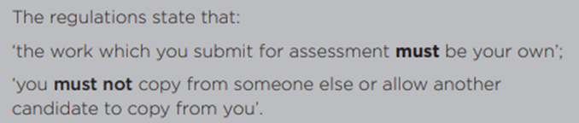

When producing a piece of work, if you use the same wording as a published source, you **must** place quotation marks around the passage and state where it came from. This is called ‘referencing’. You **must** make sure that you give detailed references for everything in your work which is not your own words. A reference from a printed book should show the name of the author, the year of publication and the page number, e.g. Morrison, 2000, pg. 29.

For material taken from the internet, your reference should show the date when the material was downloaded and **must** show the precise web page, this can be copied from the address line.

You may be required to produce a bibliography at the end of your work. Where required, your bibliography **must** list the full details of publications you have used in your research, even when these are not directly referred to, e.g. Curran, J. *Mass Media and Society* (Hodder Arnold, 2005)

Where computer-generated content has been used (such as an AI Chatbot), your reference **must** show the name of the AI bot used and should show the date the content was generated. E.g. ChatGPT 3.5 (https://openai.com/blog/chatgpt/), 25/01/20??You should retain a copy of the computer generated content for reference and authentication purposes.

**If you copy the words or ideas of others and do not show your sources in references and a bibliography, this will be considered as cheating.**



Plagiarism involves taking someone else’s words, thoughts or ideas and trying to pass them off as your own. **It is a form of cheating which is taken very seriously.**

**Don’t** think you won’t be caught; there are many ways to detect plagiarism.

* Markers can spot changes in the style of writing and use of language.
* Markers are highly experienced subject specialists who are very familiar with work on the topic concerned – they may have read the source you are using, or even marked the work you have copied from!
* Internet search engines and specialised computer software can be used to match phrases or pieces of text with original sources and to detect changes in the grammar and style of writing or punctuation.



If it is discovered that you have broken the regulations, one of the following penalties will be applied

* The piece of work will be awarded zero marks;
* You will be disqualified from that component for the examination series in question;
* You will be disqualified from the whole subject for that examination series;
* You will be disqualified from all subjects and barred from entering for a period of time.

The awarding body will decide which penalty is appropriate.

**REMEMBER – IT’S YOUR QUALIFICATION SO IT NEEDS TO BE YOUR OWN WORK**

**All the staff at St Joseph’s wish you**

